
ÒAvqK‡i cÖe„w×,
‡`k I `‡ki mg„w×Ó

Government of the People’s Republic of Bangladesh
National Board of Revenue
Income Tax Wing

Income Tax Certificate

- Particulars of the assesse :
1. | TIN | t | 197165237673/Circle-195 (Salary), Taxes Zone-09, Dhaka.
2. | Name | t | Syed Obaidullah Hel Shafi
3. | Husband’s Name | t | Late Syed Abdullah Hel Kafi
4. | Mother’s Name | t | Late Khursheda Khanam
5. | Present Address | t | 269 DOHS Baridhara, Lane 3, Dhaka Cantonment, PO: 1206, Cantonment, Dhaka, Bangladesh.
6. | Permanent Address | t | Do.
7. | Previous TIN (10 digits) | t | Not applicable
8. | Status | t | Individual.

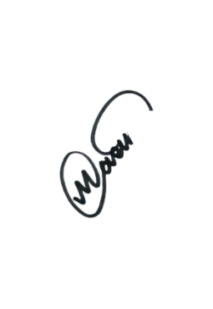
This is to certify that Syed Obaidullah Hel Shafi is an assessed of Circle-195 (Salary), Taxes Zone-09, Dhaka. Assessment of the assesse has been completed for the assessment year 2026-2027 under universal self-assessment scheme.
(Md. Masum Billah)
Deputy Commissioner of Taxes
Circle-195 (Salary),
Taxes Zone-09, Dhaka.
Phone: 02-7914098.

ÒmevB wg‡j †`e Ki,
‡`k n‡e ¯^wbf©iÓ

Government of the People’s Republic of Bangladesh
National Board of Revenue
Income Tax Wing

Income Tax Certificate

- Particulars of the assesse :
1. | TIN | t | 197165237673/Circle-195 (Salary), Taxes Zone-09, Dhaka.
2. | Name | t | Syed Obaidullah Hel Shafi
3. | Husband’s Name | t | Late Syed Abdullah Hel Kafi
4. | Mother’s Name | t | Late Khursheda Khanam
5. | Present Address | t | 269 DOHS Baridhara, Lane 3, Dhaka Cantonment, PO: 1206, Cantonment, Dhaka, Bangladesh.
6. | Permanent Address | t | Do.
7. | Previous TIN (10 digits) | t | Not applicable
8. | Status | t | Individual.

This is to certify that Syed Obaidullah Hel Shafi is an assessed of Circle-195 (Salary), Taxes Zone-09, Dhaka. Assessment of the assesse has been completed for the assessment year 2025-2026 and taxes thereon paid in full. ===========
(Tanusree Chanda)
Deputy Commissioner of Taxes
Circle-195 (Salary),
Taxes Zone-09, Dhaka.
Phone: 02-7914098.

